London City Airport expansion consultation

Briefing July 2022

Summary
These notes are in response to a development proposal by London City Airport, in which they propose to extend their operating hours to all day Saturdays, operate more aircraft in the early morning and late evening and increase passenger numbers from 6.5 million to 9 million per annum. London City predicts this will mean flight numbers will be 110,000 per year by 2031, close to the legal limit of 111,000 and up from around 50,000 at present and a little over 83,000 in 2019, the last full year before Covid. T

These notes are intended for policymakers and those with an interest in preparing a response to the airport’s consultation.

- Suggested lines to take
- SE London and London City flight paths – the current position
- New proposals – the key new points for SE London
- ‘New generation’ planes – are they quieter and if so, where?
- Alternative approaches for London City Airport
- Airport expansion in London and the UK – wider context
Appendix 1. Taylor Airey Report (2022 commissioned by Heathrow)
Appendix 2. Continuous Descent Approaches and noise

1. Suggested lines to take for SE London

The 24 hour weekend ban must be protected
The 24 hour no flying ban is part of a package of planning permissions agreed by the airport with Newham. It is there to protect Londoners from aircraft noise. That protection is needed more than ever now. London City plans to increase flights from a current 50,000 per year to a pre pandemic level of 80,000 per year and then 110,000 per year. There is no justification for ending the 24 hour ban.

SE London’s parks and gardens must remain protected from London City Airport on Saturday afternoons and evenings. Londoners should not have to pay for aviation expansion with their health and wellbeing.

Flight paths need to change before any other expansive proposals
The significant level of aircraft noise experienced by SE London residents under London City’s concentrated arrivals flight path is already set to increase hugely within existing planning consents.

Both City and Heathrow airports’ flight paths go across SE London – for the detail see section 2. The Airport should not apply for any further flight expansion or change of hours at the very least until the aircraft noise problems caused by London City’s low altitude concentrated arrivals flight path and the crossing of its flight paths with Heathrow over SE London have been satisfactorily resolved.

New generation planes are not noticeably quieter over SE London
There is no evidence to date that new generation planes are noticeably quieter over SE London than the models they replace. They will only be significantly quieter for all overflown Londoners if they fly higher, use Continuous Descent Approaches and use alternating routes.

London City Airport has provided no evidence that new generation aircraft are noticeably quieter as they fly a near-level concentrated path over the same homes every time some 2000 feet over SE London from some 32km/20 miles from landing. Doubling (from today’s level) the number of flights simply doubles the disturbance.

These new planes only help reduce noise noticeably for communities close to the airport runway, inside a very small geographical area – the ‘noise contour’ area - where London City measures and reports on its noise impact.

2. SE London and London City flight paths – the current position
The current low altitude, concentrated, arrivals flight path was introduced in 2016, despite strong opposition. It led to a massive increase in complaints from the overflown. London City’s approach was strongly criticised most recently in a Taylor Airey report commissioned by Heathrow. (Appendix 1). The regulated process for changing airspace was upgraded radically, partly as a consequence, to the CAP1616 regulation in place today.

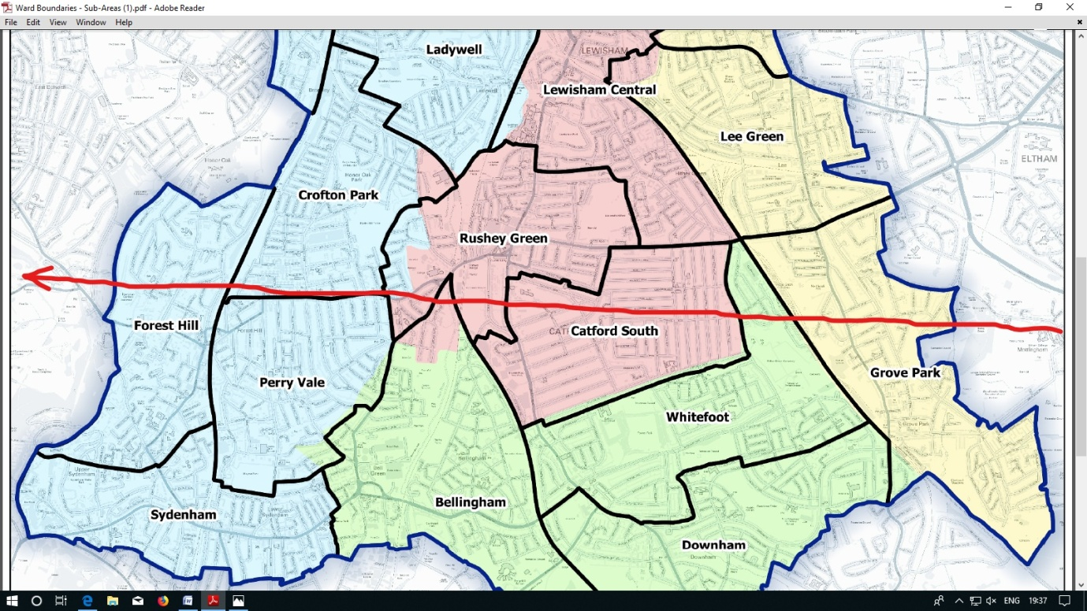
London City Aircraft fly at under 2000 feet all the way across SE London

Currently (2022) London City are operating at around 50,000 aircraft movements per year, set to rise first to pre-pandemic levels of 80,000 then to a planning permission level of 110,000 per year within their permitted operating days and hours.

Half of these are arrivals. About 40% of arrivals (depending on wind conditions) arrive low over Lewisham, Southwark, Lambeth, Greenwich and Bexley.

So on the SE London concentrated (PBN) arrivals flight path, estimated overflights are now 10,000pa, pre pandemic 16,000pa and planning permission level 22,200pa.

Without redesign of flight paths all of these flights will fly low over the same homes and gardens every time. All City flight paths are being re-designed along with those of all airports in the South East. City has recently said that this national process is heading towards completion in 2028/29. They decline to postpone development plans like the current one until that process is complete.

New flight paths should provide alternating routes to spread the environmental impacts, enable planes to fly higher for longer (Continuous Descent Approaches) and address the crossing flight path problems caused by Heathrow and London City.

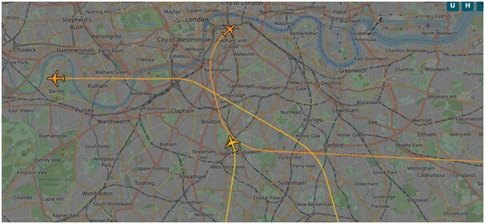
Heathrow westerly arrivals cross the London City concentrated flight path at multiple points over SE London, from Dulwich/Brixton in the west and at least as far as Eltham in the east. Source flightradar24

3. New proposals – the key new points for SE London
A non-statutory consultation was launched by the airport on 1st July 2022. It closes on 9th September. The airport says it will take feedback and then prepare and submit a planning application to Newham at the end of 2022. Newham will then need to carry out a statutory consultation and make its planning decision.

It is unclear to what extent Newham will at that time engage with other affected Boroughs. Many of the benefits claimed by the airport will accrue to Newham most of all. But the noise impacts of Saturday flying will apply across many London Boroughs, and not just in SE London.

The airport claims that by opening up to Saturday afternoon and evening flights, plus with early morning and late night flexibility, they will be able to meet rising passenger demand, in particular for Saturday leisure flying to increasing numbers of destinations. This is something they say the airlines want. They further want to increase the annual passenger limit from 6.5 to 9 million pa.

The airport claims that only new generation planes will fly in any permitted extended opening hours and that these are quieter and more efficient than the models they will replace over time. They claim that the replacement of old with new planes will be accelerated by airlines if they are permitted Saturday all day flying.

The airport says that this development proposal is entirely separate from the CAP1616 process of re-design of flight paths, but we would argue that from an environmental impact point of view the impacts of the two are unavoidably interlinked and should be considered as a whole.

Impacts for SE London:-
We can expect to see flight arrivals over SE London grow from 10,000 to 22,200 flights pa.
City Airport does not need new planning permission to do this.

An increasing proportion of these flights would shift to Saturday afternoons and evenings – indeed, it is possible, if unchecked, to see Saturday quickly becoming their busiest day of the week.
Current planning permissions allow up to 45 aircraft movements per hour during operating hours

The 24 hour weekend ban was put in place to protect overflown Londoners from the airport’s operations and as a condition for City’s permission to increase their flight movements. There seems no good reason to remove this protection from Londoners.

Flying ‘quieter’ planes in these extended operating hours does not help the overflown. Our homes, parks and gardens on Saturday afternoons and evenings currently have no City Airport planes. No new plane can ever be quieter than that.

Despite the national project slowly progressing to redesign flight paths we remain concerned about crossing of new PBN flight paths:
- some communities being under both a London City takeoff and arrivals flight path
- some communities being under two different London City flight paths in different wind conditions,
- the same communities being under one or more London City and Heathrow arrivals paths.

4. ‘New generation’ planes – are they quieter and if so, where?
Close to the airport runway the airport measures noise contours carefully – it is required to do so by Newham. All of its focus is on these areas, and new gen aircraft claim a carefully worded ‘60% smaller departure noise footprint’ on takeoff in those closely defined areas. The City consultation sets great store by this.

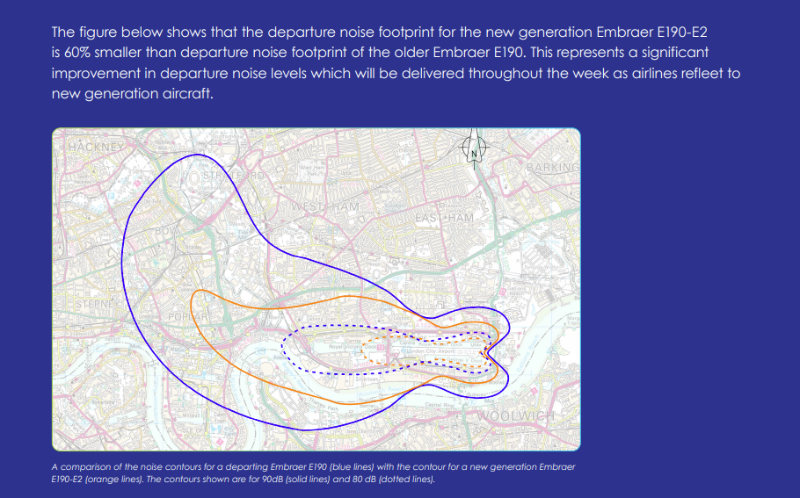

New gen planes are listed as two types currently in service in a very small proportion of London City flights – Embraer E190-E2 and Airbus A220-100.

But in level flight arrivals across SE London the noise picture is far from rosy. London City noise consultants claim, without presenting any evidence, that we might expect a 2-3 decibel reduction from the newer planes. And the CAA says that a 3dB difference is ‘just noticeable to the human ear’ (see Appendix 2). So a claimed 2-3 decibel difference will appear from the ground just as disturbing as an older generation plane.

And instead of current operating hours they would be over us all day Saturday as well.

It gets worse. Using an aircraft noise app devised for the purpose (Explane) we have recently been measuring the decibel max levels of aircraft at several points along the low altitude SE London flight path. It is extremely difficult to distinguish any difference between new generation and older models by ear alone. And it stretches our early, measured data to say we are seeing even a 2 decibel reduction.

In short, new gen planes are not substantially or noticeably quieter over SE London than those they will replace. Giving up quiet afternoons and evenings on Saturdays will deliver no noise benefit to SE London residents.

Conversely, the flight path redesign project, introducing a Continuous Descent Approach, could deliver a significant and noticeable 5dB reduction over SE London (see Appendix 2). This is why we need to wait until the new flight paths are implemented before considering any change to operating hours, whatever planes London City and its airlines decide to fly.

5. Alternative approaches for London City Airport
In their consultation pack is a chart showing growth for the airport with and without the new development plan. It shows that the airport can grow without this development, but at a slower rate.
Saturday flying will deliver faster growth of aircraft movements and passengers, travelling in larger planes.

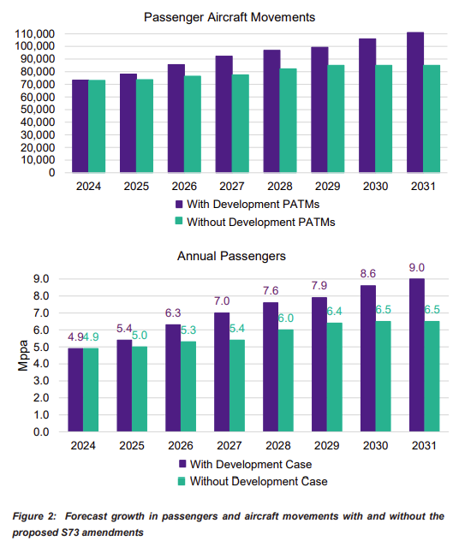
City has other options though. Firstly, they should complete the flight path project while operating within their current planning conditions. Once they are flying higher, using a Continuous Descent Approach for landings, have respite routes and have resolved flight path conflicts with Heathrow, they will have a far better case for change, including of course flying a greater proportion of new generation planes on the new routes.

City claims that the proposed development will incentivise airlines to re-fleet earlier. But airlines will have to re-fleet anyway over time. In the absence of any changes in flight paths we would say that the slower growth path is by far the more acceptable option for Londoners.

As the airport says in its consultation document :-‘Without the proposed amendments, the area of the noise contours will reduce more slowly, due to the slower transition to new generation aircraft, albeit by 2031 the noise contours will be slightly smaller overall because of the curtailed number of aircraft movements at this time.” In effect, the noise situation will be better overall without the development than with.

There are other ways to incentivise airlines – through differential landing fees for new generation planes for example. This would keep the transaction within the aviation industry and not require Londoners to pay for this faster re-fleeting by sacrificing their quiet weekend time and health.

6. Airport expansion in London and the UK – wider context

There seems an increasing clamour, not just from the usual campaigners, for climate action policy to include flight demand reduction measures – frequent flyer levies, taxation of aviation fuel etc- at Government level. The current Government is committed to its Jet Zero plan, developed with the industry but widely criticised as being a green light to unlimited expansion of aviation.

‘Dan Norris - The West of England mayor is urging the Government to join up its response to the proposed expansion of up to 20 regional airports after campaigners against Bristol's won an initial High Court ruling.
Dan Norris says that while he has no power over the issue, he has "moral imperative to lead on this" and is backing calls for the Levelling Up, Housing and Communities Secretary, Michael Gove, to end the current piecemeal approach where each airport's plans are considered separately.
He said: "If you believe there is a climate emergency, and I certainly do believe that, we have to make decisions about how we deal with that, and that does not mean expanding airports, it means that the national Government has to take the lead because they have to coordinate all the different airports.’

Of course City Airport makes claims about employment and benefits to the economy if this goes ahead. They also major on the quieter new generation planes – a major plank of their case is that airlines will re-fleet faster and the overflown will ‘benefit’ from this throughout the week.

But as we have seen, aside from very close to the airport, the only thing that will make a noticeable difference (over 5dB) to the overflown is flying higher and alternating routes – not expected until 2028/29.

Appendix 1 - Taylor Airey Report (2022 commissioned by Heathrow)

Heathrow airport commissioned a report to look into the introduction of concentrated flight paths (PBN) at airports around the world. London City Airport was criticised for what it did in 2014-16.

Lessons Learned: Response to Taylor Airey’s PBN Implementation Benchmarking Report July 2022

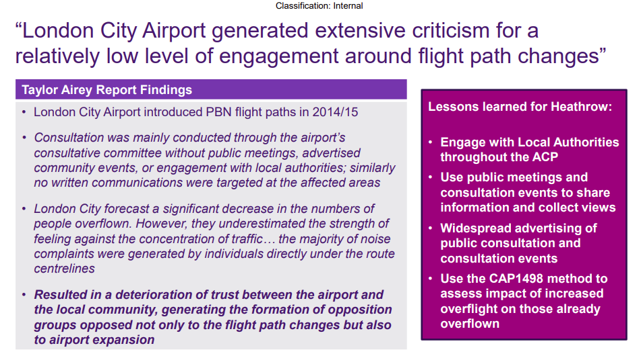

Appendix 2. Continuous Descent Approaches, aka Continuous Descent Operations (CDO)

London City arrivals in east winds use a Conventional Approach to reach Sidcup, about 20 miles from landing, at around 2000 feet. Flying level or in small steps over all of SE London requires additional thrust, creating more noise, as illustrated by the Civil Aviation Authority below.

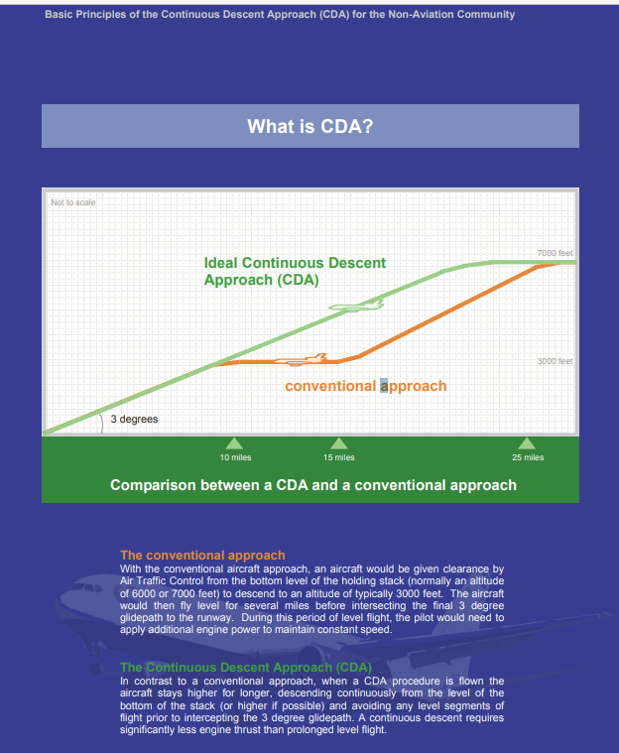

A change of 3 decibels is ‘just noticeable to the human ear’ according to the CAA. Yet new generation planes are not measured at even 3 decibels quieter over Lewisham. But flight paths using a Continuous Descent Approach could give up to 5 decibels of noise benefit.
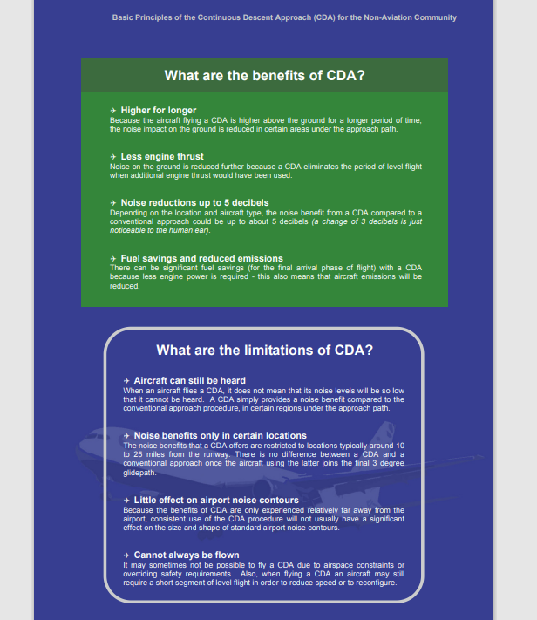

Selected information sources
HACAN East – the aircraft noise campaign group focused on London City Airport
Hacan East — HACAN East

London City Airport Consultation London City Airport | Future Plans

Metro mayor Dan Norris urges Government to end piecemeal approach to airports' expansion plans | Local News | News | Midsomer Norton Nub News

