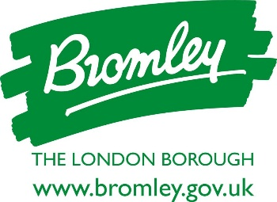
London Borough of Bromley Content Release

April 2022
For immediate release

Ticketing launches for Bromley Platinum Jubilee celebrations
Bromley residents can come together to celebrate the Queen’s Platinum Jubilee with free tickets now available for fantastic Outdoor Concerts and movie screenings at Queen’s Gardens.
The commemorative concerts, which feature a host of fabulous local talent, run alongside al fresco film screenings delivered by Your Bromley. The performances promise to take inspiration from all things royal and the 70 glorious years of Her Majesty The Queen’s reign.
Groups including Magpie Dance, Bromley Vocal School, Skylark Dance and Spotlights Theatre, with more to be announced, will perform during the evenings of 3 and 4 June. The latter will be followed by a live screening of the Party at the Palace.
The live concerts will be preceded on 2 June, and in daytime sessions on 3 and 4 June, by screenings of films with a royal connection including The Lion King, Beauty and the Beast, Frozen, Shrek, Minions and Bohemian Rhapsody. Tickets to all film screenings will be free and some deckchairs will be available to hire in return for a charity donation of £10.
Bromley residents are encouraged to take advantage of the free entertainment and come together to sing, dance, enjoy music, theatre, films and much more on this unique occasion. Drinks and food outlets will be serving within the Gardens, but residents can also bring their own picnics to the celebration.
Full information about session times and how to book the free tickets can be found at https://queens-gardens-platinum-jubilee-celebrations.eventbrite.co.uk
A spokesperson for Bromley Council said: “We are delighted to be able to help bring Bromley residents together as a community to celebrate an incredible milestone and the wonderful achievements of Her Majesty The Queen over the last 70 years. The concerts at Queen’s Gardens are at the heart of a variety of events taking place all across the borough giving everyone a chance to get involved in this once in a lifetime celebration.”
Frances Forrest, BID Manager at Your Bromley added: “We are delighted to be working with London Borough of Bromley to mark this unique occasion. We are also taking the opportunity to join the efforts made by the London Borough of Bromley and Bromley residents to help the people of Ukraine at this unprecedented time, so will be donating all proceeds from deckchair hire at the Queen’s Garden events to Ukraine Disaster Emergencies Committee.”
The Queen’s Garden events are among many being staged in the Borough to mark the Platinum Jubilee, from the lighting of a beacon in Crystal Palace Park, one of 1500 that will be lit across the country, to some 300 street parties happening Borough-wide. Other commemorative activities include children’s art challenges and storytelling activities, a parade by uniformed organisations, the planting of more than 1500 trees as part of the Queen’s Green canopy initiative and a talent show and Street Party organised by Your Bromley on Sunday 5 June.
More information about the events being staged across Bromley as part of the Platinum Jubilee celebrations can be found at www.bromley.gov.uk/platinumjubilee
ENDS
For media enquiries, please contact James George, Public Affairs Officer, on 020 8313 4565 or email james.george@bromley.gov.uk

