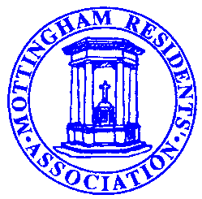
NOTICE OF A SPECIAL GENERAL MEETING

of the

MOTTINGHAM RESIDENTS’ ASSOCIATION to be held on

Wednesday 21st October 2021
at St. ANDREW’S CHURCH HALL, COURT ROAD,
MOTTINGHAM SE9 at 7:30 pm

All residents of Mottingham are welcome to attend, whether or not they are Association members.

AGENDA
- Apologies
- Minutes of the AGM 2019
- Approval and ratification of measures taken by the
Committee during, and as a consequence of the Covid Pandemic.
- Chairman's Report
- Membership Secretary’s Report
- Treasurer's Report – to receive and adopt the audited accounts
- Election of Officers and Executive Committee Members
- Any other business

We have not arranged a speaker for this meeting, but refreshments will be
Served at the conclusion of the formal meeting, to facilitate a general discussion
and to provide an opportunity to meet and question Committee members and local Councillors.

MRA and Social Media

The MRA Executive believes it is time we caught up with the rest of society and increased our use of social media. Our website, www.yourmra.org has copious information with links to other websites and relevant services and activities. We strongly recommend that residents visit the site and we would welcome feedback and suggestions for additional information or further improvements, to webmaster@yourmra.org. or via contacts links on the site

Your Association needs YOU

To enable us to make the most of other Social Media platforms, such as Facebook, Twitter etc., we really need a new volunteer with expertise in this area. If you feel you may be able to help or suggest someone else who might be willing, then please do contact either the Chair, Secretary or webmaster through the website.

The MRA urgently needs more Road Stewards to help collect subscriptions and deliver newsletters etc. We currently have specific vacancies for Bowmead, Bill Hamlin Close, Birbetts Road, Downleys Close, and also parts of Beaconsfield Road, Chapel Farm Road, Leysdown Road, Mottingham Lane and Mottingham Road. Help in other areas would enable us to reduce their size, so any offers of assistance would be appreciated. If you can spare a few hours a year to help or would like further information, please have a word with any member of the Executive Committee at the Special GM or email membsec@yourmra.org .

MRA Privacy Policy:
The MRA obtains Personal Data (such as names, addresses, phone numbers, email addresses) from members. This data is obtained, stored and processed solely to assist volunteers in the efficient running of the organisation. Personal details supplied by members are only used to send them material about MRA activities and information that is considered potentially useful. Personal Data is stored either on the MRA database or in hard copy. It is MRA Policy that no Personal Data will be released to any third parties without the individual’s consent.
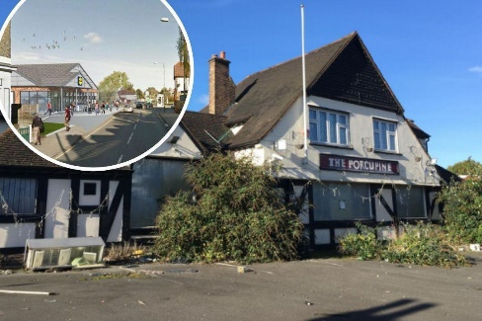
News Update – Urgent –
The former Porcupine site. Reply required before October 14th

Residents may be aware that the appeal made by Lidl following Bromley’s latest refusal of planning permission is about to be heard. This will be carried out under a written submission procedure and any comments should be submitted by October 14th either by post (in triplicate) or via email to RT1@planninginspectorate.gov.uk quoting the reference APP/G5180/W/21/3274124. Information about the process can be found at https://www.gov.uk/appeal-planning-inspectorate Using the Appeal number 3274124
DATES FOR YOUR DIARY: (Check www.yourmra.org for up-to-date information and starting times.)

The Remembrance Sunday service will be held on 14th November 2021 outside the Warr’s dealership and around the War Memorial roundabout commencing at 10:30.

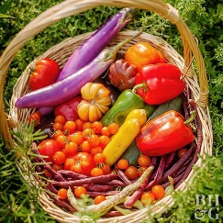
Mottingham Horticultural Society.

If you love your garden, why not join – only £2.50 per annum.
The society has an autumn show at Eltham College, holds plant sales,
and a Christmas Gathering.
Their next event is due to be a tour of Avery Hill park on 21st October at 2pm.
If you are interested please email The Secretary: Elizabeth Walker, email: elizabethwalker114@hotmail.com

Mottingham Floral Arrangement Society.

The MFAS meets at 7.30pm on the third Wednesday of each month in the Chris Mumbray Hall, St. Andrews Church where demonstrations in the latest flower arranging techniques are given by experienced NAFAS accredited flower arrangers from around the country. Dates for the next scheduled meetings are:

Programme for 2021-22

2021 – Oct 20th, Nov 17th
2022 – Feb 16th, Mar 16th, Apr 20th, May 18th, June 15th, July 20th, Aug 17th, Sept 21st, Oct 19th, Nov 16th.

Further details are available from: The Chairman: Astrid Chklar, email: astridchklar@yahoo.co.uk
Mottingham Village Concert Band.

The band plays on various occasions and at special events during the year – it may even be available for yours!

New competent brass or wind players always welcome to come to rehearsals on Wednesday evenings (term-time) at 7:45 pm in the Leysdown Church hall.

Further details available from: www.mottinghamband.co.uk or email at mvconcertband@gmail.com

MRA Executive Committee meetings are usually held on the evening of fourth Thursday of January, March, June, September and November in the Chris Mumbray Hall commencing at 7.30pm. Any changes will be noted on the YourMRA website.

Police contact numbers: In an emergency always dial 999 but in less urgent situations dial 101.
The current Safer Neighbourhood Teams are:

Bromley: Mottingham and Chislehurst North ’team’ is:  PCSO Sue Kennedy.  Contact via Bromley Police Station High Street BR1 1ER  Tel: 020 8721 2889 (not manned 24/7).  Email: ChislehurstNorth.snt@met.police.uk  and on twitter @MPSMottChisNth | Greenwich: The Greenwich team are:  PC Andy McDermott & PCSO Dave Glock.  Contact via Coldharbour SNT  60 William Barefoot Drive SE9 3AY  Tel: 020 7161 9521 or 020 8284 5625.  Email: Coldharbour.NewEltham.SNT@met.police.uk

