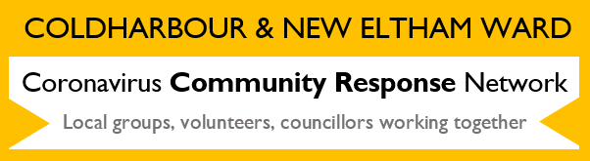
RBG Community Hub
If you need help because you are vulnerable and self-isolating, and have not got a family member, friend or neighbour who can help, our volunteers could provide support with:
- collecting / delivering prescriptions
- delivering essential food packages
- connecting you to local community services.
covid19support@royalgreenwich.gov.uk
Phone: 0800 470 4831
Update from Covid-19 Mutual Aid

Requests for help from Coldharbour and New Eltham Covid-19 Mutual Aid group can be made via:
WhatsApp groups: https://chat.whatsapp.com/EG0jh3s0R2Q3qUSrKjZWhx
Google form: http://bit.ly/GwichMutualAid
Greenwich Covid19 Facebook group: https://www.facebook.com/groups/GreenwichCovid19MutualAid/
Volunteers can sign up here: http://bit.ly/GwichMA

