MRA Response to the Consultation Document from The Spring Partnership Trust (TPST) for the Amalgamation of Dorset Road Infant School and Castlecombe Primary School.

Consultation on the amalgamation of Dorset Road Infant School and Castlecombe Primary School

Infant School and Castlecombe Primary School

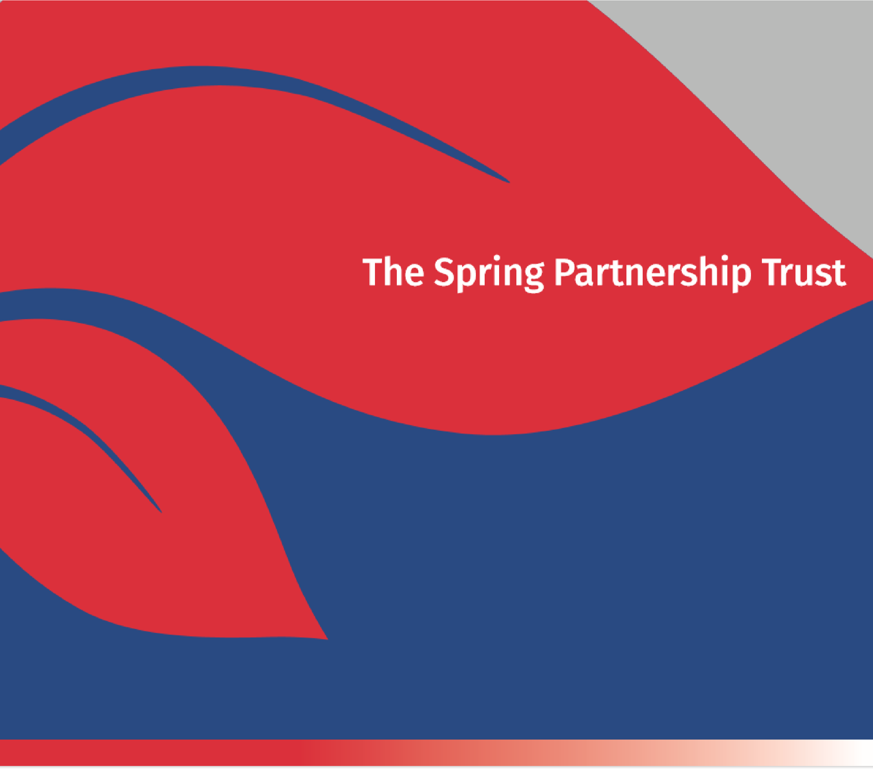
This document is drawn up based on the proposal document issued by TPST. Comments annotated in GREEN represent the response of the Mottingham Residents’ Association (MRA) to each section.

All sections from the document are presented unaltered, although not all are commented upon by the MRA. .

Putting children’s education and safety first

Our proposal
The Spring Partnership Trust is proposing to discontinue Dorset Road Infant School and Castlecombe Primary School and amalgamate them to form a new primary school on the Castlecombe site.

The amalgamation process
Dorset Road Infant School currently takes children from age 4 to age 7, and Castlecombe Primary School from age 4 to 11. Both schools are rated ‘Good’ by Ofsted. At the point of implementation, a primary school will be created with an age range 4 to 11. All pupils currently at the two schools will be guaranteed a place at the amalgamated school.

If this proposal goes ahead we will be seeking further input from parents/carers, staff and pupils regarding the details of the new school to make sure the school community are involved with any decisions.

Why are we consulting on the amalgamation of Dorset Road Infant School and Castlecombe Primary School?
- It is increasingly difficult to meet pupil’s educational needs with a very small staff team.
Many schools operate successfully on more than one site. Resources are shared between sites according to the needs of pupils.

- The Dorset Road site is significantly below the necessary level of compliance in terms of the government guidelines for school buildings. Furthermore, the Dorset Road School hall needs extensive and costly repairs.

If all schools which did not comply with government guidelines for buildings or site, were closed, many thousands of pupils would be without a school place across England. The National Audit Office estimated that it would cost £6.7bn to bring existing schools up to a satisfactory standard. (Reported in The Guardian, 8th December, 2019.)

What are the benefits of amalgamation?

The amalgamation will provide: -
- greater opportunities to further enhance educational standards due to a greater range of staff knowledge, skills and experience;
A Trust with a single school or any number of schools, has a responsibility to ensure that staffing resources are equitably shared according to pupils’ needs, following assessments and referrals.

- the ability for all pupils to benefit from more outdoor learning experiences;
Pupils at Dorset Road benefitted from a nature area, seasonal flower/shrub bed and raised, produce growing bed. The former have been sadly neglected and the growing bed has disappeared since the Trust took over. The school uses Eltham College grounds for Sports Days & have access to Mottingham Playing Fields & The Tarn, both within easy walking distance to meet curriculum needs.

- greater capacity for early special educational needs assessments and referrals, and enhanced special educational needs provision;
Pupils should have equal right of access to support irrespective of location.
- access for all parents/carers to the nursery and wrap around care based at CPS.
DRIS pupils had access to a breakfast club and extensive after school clubs. Since attending Castlecombe they have had neither breakfast club nor access to the wrap round care which is available to Castlecombe pupils.

Families will also benefit from their children attending one site, as well as having access to a thriving breakfast and after school club for their childcare needs.
The proposed single site, at Castlecombe, is a 22 minute walk, uphill, from Mottingham Village, more if parents have a pram or younger child or elderly carers/grandparents are involved.

Impact on stakeholders
Staff - The impact on staff is being kept to a minimum. There should be no direct impact on teaching, class support and ancillary staff as a result of this proposal.
However, the Deputy Head is taking redundancy and the Administration Officer has left. Cleaning and maintenance were much reduced at DRIS. Parents were obliged to clean the toilets and sweep the playground. DRIS staff remain committed to their school & the advantages of a small school serving young children within their own community.
Pupils – the main impact on existing DRIS pupils would be that their school would be located on a different site. Pupils would have continuity with their teachers and support staff. There would be no change of school site when they transferred to junior school in Y3.
Parents/carers – Some parents may have to travel further to get to the site of the new school. However, if parents have siblings at nursery, or in different key stages of the school, they will only have to travel to one site to escort their children to and from school.
- Denial of choice of a small school close to homes. National guidelines for school place provision, recommend a 10% excess to allow parental choice and movement in and out of the area. Bromley policy recommends 5%
- Transfer to Castlecombe, without notice resulting in upset to pupils and great inconvenience to parents/carers, particularly those with jobs or family commitments. No efforts have been made to integrate DRIS pupils into the school as a whole.
- A disproportionate effect upon those with Special Educational Needs. A local Councillor acknowledged, at an MRA meeting on 23rd January, 2020, that increasing numbers of parents with pupils who have Special Educational Needs, were choosing DRIS.
- Parents/carers have specifically chosen DRIS to meet their child’s needs, accepting the necessity of a change at age 7.
- No other small school in Bromley is under threat of closure. Other Trusts have taken their responsibilities seriously.
Local community –TSPT believes that this amalgamation has the potential of improving community involvement in the schools. A single community / parent group should lead to greater engagement with the community as individuals and businesses would not need to choose which school to support when time and resources are limited. The new school would be bringing together elements of best practice when it comes to community engagement.
When the Trust took over, the school was an integral part of the village community, Community members regularly read with the children, the Mottingham Residents’ Association held their meetings in the school and members of the Mottingham Horticultural Society helped with the nature area. Pupils made decorations for the Community Christmas Tree and contributed horticultural pictures to the annual Horticultural Show. (Brownies & Rainbows now undertake these tasks.) All these contacts were systematically stripped away by the Trust.

The whole school sang songs at the Library Christmas Coffee Morning & visited regularly to borrow books and listen to stories. They continue to do so, thanks to the dedication of DRIS staff.
The DRIS PTA continues to be active in supporting the school through fundraising, social activities for pupils and families, and a popular, child-friendly, Christmas Fayre. The PTA is adept at engaging with local businesses who have always supported DRIS.

There is no effective parents’ group at Castlecombe and no history of Library visits or fundraising by Castlecombe School in Mottingham Village.

An equality impact assessment has been carried out in relation to this proposal.
A request for a copy, under Freedom of Information legislation, has been made. On receipt, it will be displayed on the website.

Admission arrangements
The current round of applications for places for children due to start school in September at both Castlecombe Primary School and Dorset Road Infant School is not affected by this proposal. All applications made to these schools are being considered in the same way as they would be if the site at Dorset Road had not been affected by health and safety concerns, as the school is still in operation - albeit at a different location. Primary school applications to Dorset Road will be awarded based on the criteria as shown in the TSPT admissions policy, with the proximity criteria continuing to be measured from the location of the Dorset Road site, even though it is temporarily closed.
Recruitment to DRIS has been directly, and dramatically affected by the actions of the Trust.

- For 2016 & 2017, 30 places were offered and high 20s were accepted.
- For 2018, 30 places were offered, with around 25 accepted. The Hall was closed at around the time pupils started school resulting in a number going elsewhere.
- For 2019, with the school hall still unrepaired, many parents were fearful of choosing DRIS and around 15 pupils started.
- Recruitment for September, 2020, began in the Autumn Term 2019, with the Hall still unrepaired. The only poster advertising the Open Day was on an A5 sheet displayed in a single shop window. It is not surprising that the Open Day was poorly attended. In October, the pupils were moved, overnight, to Castlecombe. The two remaining Open Days in November, 2019 & January 2020, were held at Castlecombe Primary School. DRIS remained closed. The Trust made no attempt to advertise places at Dorset Road. The only publicity was a poster placed on DRIS’ railings by parents. There is little doubt that these actions by the TSPT will have damaged recruitment.
- The DRIS site is described as “closed temporarily”. However, parents’ repeated requests to fund their own survey and quotation for repair, have not been acceded to. The Trust is insisting on the replacement of the Hall.

What is the background to this situation?
- 2016 - DRIS and CPS joined The Spring Partnership Trust (TSPT). The TSPT plan was to expand DRIS to 90 places and to expand CPS in KS2 so pupils from DRIS would have a guaranteed place there in the junior part of the school (KS2)
The Spring Partnership Trust (TSPT) took over DRIS. Firm assurances were given to the community, through the MRA, that Dorset Road would remain open. However, it soon became apparent that these assurances were worthless. The TSPT 2015 Annual Report & Financial Statement, (p. 6), states that the intention was that DRIS would join “in the short term…..” https://www.springpartnershiptrust.co.uk/attachments/download.asp?file=27&type=pdf

- 2017 - A Staffing restructure took place at CPS and DRIS, resulting in one headteacher shared across both schools and a shared leadership team. Local committees merged in 2017.

2017 - DRIS expanded from 75 pupil places to 90 pupil places. 4 new classrooms, a library, an arts studio and a nurture room were built at CPS for DRIS pupils to transfer to in Y3 for KS2.
2017/18 - Despite the stated short term intention for DRIS, two Government CIF grants were received for improvements to security & remodelling the kitchen, office & facilities for the disabled at the school.

- 2018/19 - As a consequence of building work to expand the kitchen at DRIS so that 90 pupils could be catered for, significant structural problems were identified in the school hall, estimated to cost circa £500,000 to rectify. Applications for funding from the DfE have been unsuccessful.
2018 - A previous repair to the Hall was damaged during building work. The Hall was closed & a series of Acrow supports were installed. Despite three survey reports, no further action was taken. The MRA was told repeatedly that funding had been applied for.
2019 – The pupils were moved to Castlecombe overnight, without notice, on 9th October 2019. The Trust maintained that the Hall was in danger of collapse. Tell-tale monitors were placed in the Hall for 2 months, with no movement detected. In December, the support Acrows were removed & still no movement occurred. No date for the return of pupils to DRIS has been agreed by the Trust.
2020 - Parents continue to seek permission to undertake their own survey and cost estimate for repair of the Hall. This has not been granted. No date for the return of pupils to Dorset Road has been agreed to, despite requests. Pupils remain “in limbo” with no prospect of resolution. They are not being made welcome at Castlecombe School and are looked upon as interlopers.

It is clear that the Hall needs repair. However, the Hall suffered the same, minor, structural issue in the 1990s & 2008. In 2008, the repair was undertaken during one half term without any disruption to pupils and at very little cost. The TSPT 2019 Annual Report & Accounts https://www.springpartnershiptrust.co.uk/attachments/download.asp?file=2361&type=pdf (p 47) show that a DfE Capital Grant of £629,407 was received in 2019. Total cash reserves stood at £1.082m, in December, 2019. A small fraction of that would repair the Hall at Dorset Road.

What is the guidance from the Department for Education about amalgamating schools?
The Department for Education (DfE) has set out the requirements and processes for amalgamating and making changes to schools in the guidance ‘Making Significant Changes to an Academy and Closure by Mutual Agreement’ (Nov 2019).
A copy of the guidance “Making Significant Changes to an Academy and Closure by Mutual Agreement” is available by clicking here! https://assets.publishing.service.gov.uk/government/uploads/system/uploads/attachment_data/file/847451/Significant_change_and_academy_closure_151119.pdf
Thus far, the consultation process does not appear to have followed the guidelines.

The purpose of the guidance is to ensure that Multi-Academy Trusts (MATs) do not make decisions that will have a negative impact on other schools in the area, and that changes can be implemented quickly and effectively where there is a strong case for doing so. It is also expected that, where possible, additional new places will only be provided at schools that have an overall Ofsted rating of ‘good’ or ‘outstanding’.

The guidance also sets out the processes required to implement this proposal, and this consultation period is the first stage in that process.

Who will be consulted?
The Spring Partnership Trust (TSPT) wishes to seek the views of all those with a likely interest in the proposal. It is important that stakeholder views can be taken into account before decisions are made. We are therefore consulting with the community, potential users and other relevant stakeholders.
Consultation with representatives of the local community has been non-existent to date.

An online survey will be available on the DRIS and CPS websites, or a response form is provided below. Consultation drop-in sessions will also be run over the next 6 weeks. The dates of these sessions will be emailed in the near future.

Your views will be taken into account by the TSPT Board of Directors and the Regional Schools Commissioners office.

The following parties will be consulted in relation to this proposal:
- Each Local Authority which maintains an Education Health and Care Plan (EHCP) or statement of SEN in respect of a child attending the schools;
- Parents of children who attend the schools;
- Staff who are currently based at the schools;
- Parents in the area;
- Primary, secondary, alternative provision and special schools in the area.

How to make comments
We would like to hear your views on these proposals. You can let us have your views in the following ways: -
- responding to the online survey that is on the school websites, or
- completing the form below and emailing it to contact@springpartnership.co.uk, or
- completing the form below and posting it to Jo Brinkley, The Spring Partnership Trust, George Lane, Bromley, BR2 7LQ, or
- completing the form below and handing it in to the school office at Castlecombe Primary School.

Unfortunately, it will not be possible to acknowledge receipt.

All responses must be received by midnight on Sunday 8th March 2020.

It would be helpful to have the following information:

Name …………………………………………………………..
Postcode ………………………………………………………….
We will process your personal data in accordance with the Data Protection Act, which means that we will not give your personal data to any third parties.
Your comments will be anonymous - your name or anything that could identify you will not be included in any report. However, we cannot guarantee that this information will be withheld if it is requested under the Freedom of Information Act.

I am a: (please tick)
 | Pupil |  | Local resident
 | Parent/Carer |  | Local business
 | Member of Parent Teacher Association |  | Local sports group
 | Member of staff |  | Local community group
 | Local Committee Member |  | Other

At which school? (please tick)

 | Dorset Road Infant School (DRIS) |  | Castlecombe Primary School (CPS)

Do you agree or disagree that Dorset Road Infant School and Castlecombe Primary School should amalgamate to form one new school for the Mottingham community? (please tick one box)
 | I agree with the proposal |  | do not agree with the proposal

Comments - please add any further comments on this proposal in this box (continue overleaf if desired)

