Mottingham Village Concert Band
Invites you to its
Christmas Concert
Of Seasonal Music with Carols/Ballet &
show excerpts/lively solos

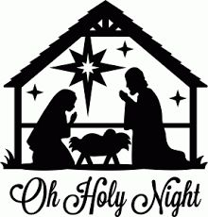

Conducted by Leslie Lake
at the Maryfield Hall (Leysdown Rd.)
(next to Our Lady Help of Christians Catholic Church)
Mottingham Road SE9

at 7.30 p.m. on Wednesday 18th. December 2019
Entrance free

