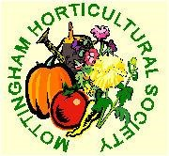

Mottingham Horticultural Society
Affiliated to RHS, National Dahlia Society and Kent Federation
Newsletter – Spring 2019

We would like to invite you to our Annual General Meeting and Spring Show to be held in the Methodist Church, Mottingham on Thursday, 21st March 2019 at 7pm. We are also pleased to say Mr Brian Nobbs will be our Speaker and his talk will be on “Gardening for Wildlife” so please try to come along for a fun evening.

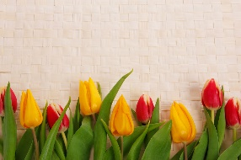
AGENDA
- To receive the President’s Report
- To read and confirm the minutes of the last AGM held on 22nd March 2018.
- To receive the Honorary Treasurer’s Report and pass the audited accounts for the year ended 31st December 2018.
- To elect officers for the coming year.
- To elect a management committee.
- Any Other Business.- to include membership review.

During a short break for refreshments, judging of the spring show will take place.

SPRING SHOW
The Spring Show will be held at the AGM with The John Owlett Cup being awarded for the best exhibit. Anyone attending the AGM can take part as there is no entry fee. Why not bring a contribution to the Spring Show? It would be super if everyone tries to enter a class to help to make a beautiful spring display which will help us all look forward to a successful gardening year ahead!
Just come along on the night and bring your flowers (and vases) with you.
The classes are:
- Single daffodil
- Vase of three daffodils
- Vase of three miniature daffodils – one variety
- Container of growing bulbs .e.g. hyacinths
- Vase of early flowering shrubs e.g. forsythia
- Vase of cut spring flowers – mixed

SPEAKER

A talk by Brian Nobbs on “Gardening for Wildlife”

