Concert
Band

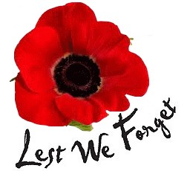

Commemorating the
Centenary of the end
of World War One

Weds 14th November 2018
at 7:30 pm

Our Lady Help of Christians Church Hall, Mottingham Road,
SE9 4ST

Mottingham Concert Band
Conductor Leslie Lake

Presents

A selection of morale-boosting songs, stirring marches and elegies for the fallen
Grand March from Aïda – Guiseppe Verdi
Keep the Home Fires Burning – Ivor Novello (1915)
It’s a Long Way to Tipperary – Harry Williams & Jack Judge (1912)
Victor Herbert Favourites – Medley of Popular Operettas
Pack up your troubles in your old kit bag – George & Felix Powell (1915)
‘Smile, Smile, Smile’ – Wilfred Owen satirical poem,
I Vow to Thee My Country – from ‘Jupiter’ Gustav Holst (1921)
The Contemptibles March – Leo R Stanley (1918)
The Middy – Kenneth J Alford (1917)
Roses of Picardy – Haydn Wood & Frederick Weatherly (1916)
Community Land – Medley of popular songs – Arr. RS Stoddon (1928)
Evening Hymn and Cavalry Last Post. – Arr. DN Taylor
‘The Last Post’ – Robert Graves poem
Jerusalem – Hubert H Parry (1916)
Pomp and Circumstance March No 4 – Edward Elgar (1907)

